# CS 255 System Design Document Template

## UML Diagrams

### UML Use Case Diagram

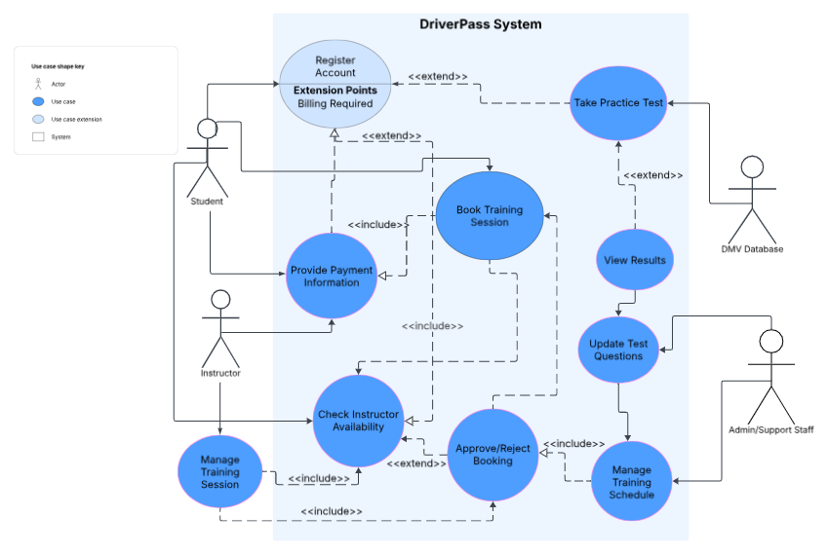

### UML Activity Diagrams

*

### UML Sequence Diagram

### UML Class Diagram

Technical Requirements

**Hardware**

* **Client-Side**: The system does not require any specific hardware for end-users. It must be accessible on standard modern devices including desktops, laptops, tablets, and smartphones.
* **Server-Side**: Since the system is cloud-based, specific server hardware is managed by the cloud provider. The provider's infrastructure must be robust enough to support at least 50 simultaneous users and ensure page load times of under 2 seconds.

**Software**

* **Client-Side**: The system must run on any modern web browser (e.g., Chrome, Firefox, Safari, Edge) across various operating systems, including Windows, macOS, iOS, and Android. No additional software installation is required for users.
* **Server-Side**:
  + **Database**: A secure relational database such as MySQL, PostgreSQL, or SQL Server is required to store all user, appointment, and test data.
  + **Web Technologies**: The application will be built using modern web standards, including HTML5, CSS3, and JavaScript frameworks, to ensure a responsive user interface.
  + **Security**: All server-client communication must be encrypted using HTTPS with SSL/TLS protocols. Sensitive data like passwords must be stored using hashing.

**Tools**

* **Development**: A version control system (e.g., Git) will be needed to manage the codebase.
* **Administration**: The system must include a back-end dashboard for IT and admin staff. This dashboard will provide tools for user management, activity log review, error reporting, and system monitoring.
* **Reporting**: A tool or library capable of generating downloadable reports in formats like Excel is required for administrators.
* **Third-Party Integration**: The system will need tools to integrate with email or SMS gateways for sending notifications and a mechanism to connect to DMV data sources for content updates.

**Infrastructure**

* **Hosting**: The system must be hosted on a secure and scalable cloud-based platform, preferably using a Platform-as-a-Service (PaaS) or Infrastructure-as-a-Service (IaaS) model. This ensures high availability (99.9%) and allows the system to handle growth.
* **Data Management**: The infrastructure must support nightly automated backups of the database, which are to be stored securely in the cloud to prevent data loss.
* **Networking**: A stable internet connection is required for all users to access the system. The network infrastructure must support secure data exchange via HTTPS at all times.